Product Design

Team < Abdulla Shamim,Ravi Teja ,Avinash,Satya Sowmith>

Architectural Model

User Interface | Component state  - Enables user to take the input as a file which can be a spreadsheet,etc.  - Enables the user to use the kettle tool and output transformed file.  Component behavior  - Displays the input and transformed output
ETL Tool | Component state  - Transform the input file  Component behavior  - transform and provides the result
Backend using Java | Component state  - Storing the input and output  Component behavior  - Component stores the user input aand transformed output into the database .

COMPONENT DIAGRAM

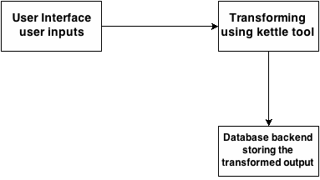

Sequence Diagram(s)

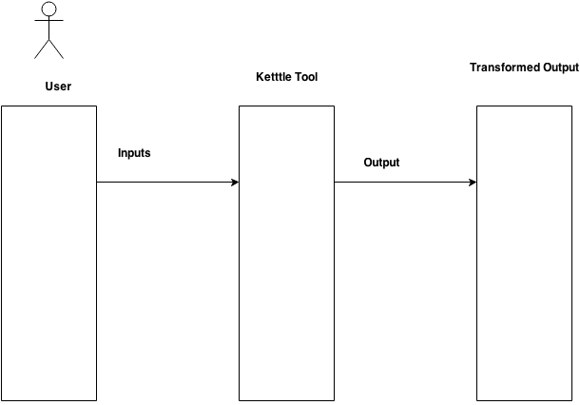

Design Rationale
The Problems initially faced by the team was that everybody was new to the ETL transformation . So measures were taken to substantially break down work for different members of the team so as to give a more productive output. we divided the work majorly by the workflow.
- The application User Interface was not so user friendly and interactive .Later we realized that it has to be more user friendly and hence better features were added to make it more interesting.
- The application was more focused on basic Input output system. However after communication with the client , appropriate changes were made to the procedure of taking the reasons from the user to make it more detailed .

